Window Lifter
Window Lifter Module Design

History
Issue status  (Index) | Maturity/Date  (draft/invalid/valid)  (dd-mmm-yyyy) | Author  AEP CES | Check/Release  AEP CES | Description
1.0 | Draft  04-0ct-09 | Alexis Garcia | Alexis Garcia | Creation of the document

Table of Contents
1 Purpose 3
2 Definitions and abbreviations 3
3 Realization constraints and targets 3
4 SW Conceptual design 3
5 SW Component internal breakdown 4
5.1 Functional Decomposition 4

Purpose
The purpose of this document is to specify the function of the module of the window lifter and the relation between his components. This includes the function of UP and DOWN with two modes of functionality , the automatic mode and the manual mode, also a validation of the button press and a pinch function for the safety of the user and prevention of accidents.

Definitions and abbreviations
Definitions
PIT | Process interrupt timer
GPIO | General Purpose Input Output
STM | System Timer Module
MCcore | Microcontroller core
one touch | Function for the automatic mode
Anti pinch | Feature that prevents accidents while the window goes up

Abbreviations
References
N° | Document name | Reference
1 | Window Lifter Requirements
2 | Traceability Matrix WL Module

Realization constraints and targets

The main purpose of this module is to provide the capability to the final user to be able to control the movement of the window in up and down direction; also this module provides a function of anti pinch, which downs the window in case of emergency of a possible accident. For a valid button press, it must last at least 10 ms, the auto mode is active if the press last for less than 500 otherwise the manual function is active while the button is press, the transition between each step of the window is 400 ms. The anti pinch feature it can only be activated in the up movement, downs totally the window and blocks the buttons for 5 seconds.

SW Conceptual design
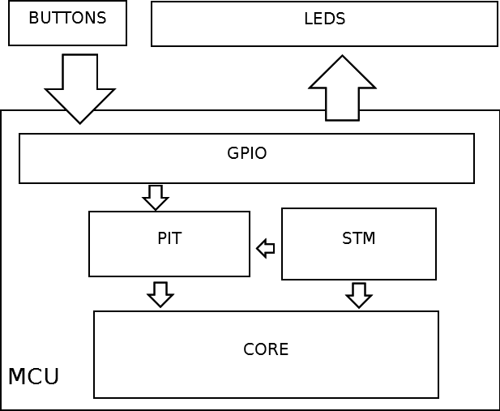

The core of the mcu is the one who controls the pit interruptions for the handling of the anti pinch feature, and the timer for the measure of the button press time, the gpio its delegate to control the communication between the mcu and the external hardware, in this case the buttons for the up, down movement and anti pinch and also the led bar that function as the simulation of the window status.

SW Component internal breakdown

Functional Decomposition
Overview of functions and their dependencies shown by a Static Function Tree
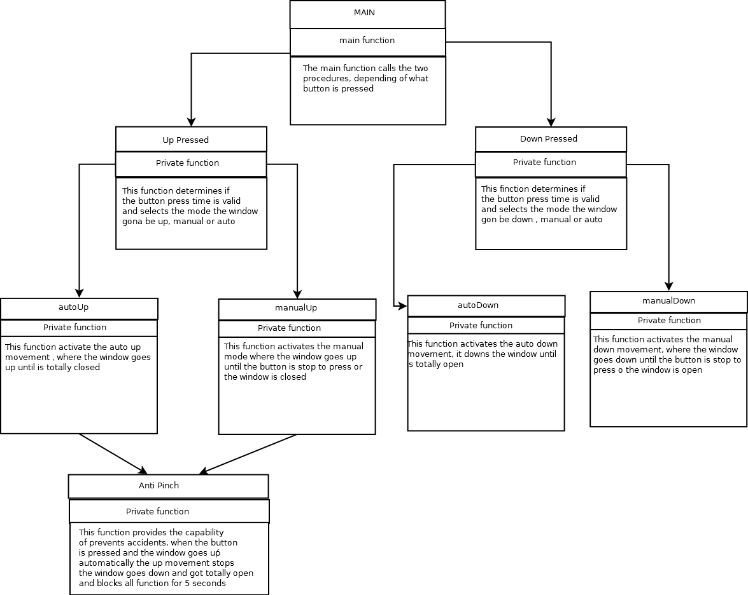
Function Description and Dynamic Behavior

Function void initGPIO (void)

Description | Configures and set the inputs and outputs from the port A to send and receive signal from and to the leds and buttons
Return Value | Void
Precondition | This is called only in the configuration before the infinite loop

Function void initTimer (void)
Description | Configuration and initialization of the SMT module to count every 1 millisecond
Return Value | Void
Precondition | This is called only in the configuration before the infinite loop

Function void delay_ms (T_UWORD luw_time)
Description | Provides a delay of the value sent in the variable luw_time in milliseconds  e.g. delay_ms(500) provides a delay for 500 milliseconds
Parameter 1  <input| output| input> | luw_time  input
Return Value | Void
Precondition | This is called each time a delay is needed

Function void initLeds (void)
Description | Sets all the leds in an initial state , red leds in on, blue and green leds in off, for demonstration and reset purpose
Return Value | Void
Precondition | This is called only in the configuration before the infinite loop

Function void downPressed (void)
Description | Called when the down button is pressed. Counts the time in ms and valid that time , if the time pressed is valid , selects manual or automatic mode and calls the respective function
Return Value | Void
Precondition | This is called on the infinite loop each time the down button is pressed

Function void autoDown (void)
Description | This function provides the functionality of automatic down, where all actual turn on leds go off in sequence until all leds are off (the window is totally open). It cannot be interrupted
Return Value | Void
Precondition | This is called only in the auto pinch and the downPressed functions

Function void manualDown (T_UBYTE *ptr)
Description | This function provides the functionality of the manual down, where from the actual led on , starts to turn off the leds (downs the window) and turns on green led, until the button is ceased to press or the window is totally open
Parameter 1  <input| output| input> | lpub_ptr  input
Return Value | Void
Precondition | This is called only in the donwpressed function

Function void upPressed (void)
Description | Called when the up button is pressed. Counts the time in ms and valid , if the time pressed is valid , selects manual or automatic mode and calls the respective function
Return Value | Void
Precondition | This function is called on the infinite loop each time the up button is pressed

Function void autoUp (void)
Description | This function provides the functionality of automatic up, where all actual turn off leds go on in sequence until all leds are on (the window is totally closed). It cannot be interrupted except for the auto pinch.
Return Value | void
Precondition | This is called only in the upPressed function

Function void manualUp (T_UBYTE *lpub_ptr)
Description | This function provides the functionality of the manual up, where from the actual led off, starts to turn on the leds (ups the window) and turns on the blue led, until the button is ceased to press or the window is totally open.
Parameter 1  <input| output| input> | lpub_ptr  input
Return Value | Void
Precondition | This is called only in the upPressed function

Function void pinchInterruption (void)
Description | This function provides a handling for the interruption in the case the auto pinch button is pressed; it can only be activated during the autoUp and manualUp functions Validates the button press time similar to the other modules, upPressed and downPressed. In case of valid press activates a flag to provide a state of anti pinch and calls for the autoDown function, finally blocks all functionality for 5000 milliseconds or 5 seconds. This function is called via PIT every 500 microseconds
Return Value | Void
Precondition | This is called only in the case of the goUp flag is true (activates only in the manual up and autoup functions)

Flow chart for functions

upPressed flow chart
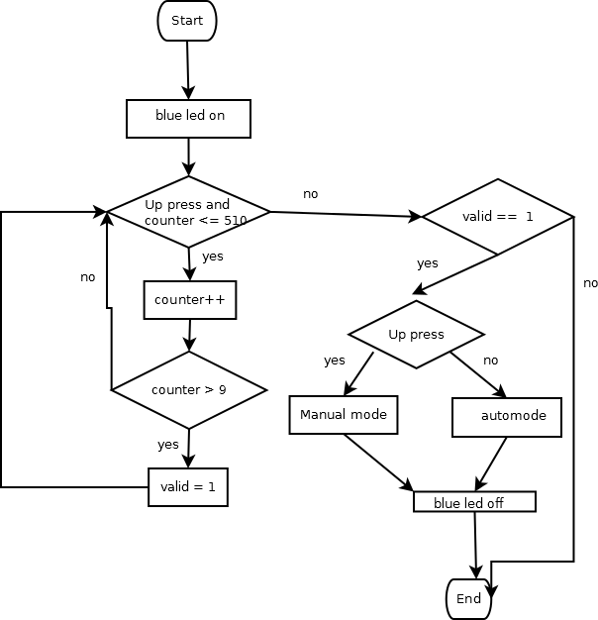

downPress flow chart
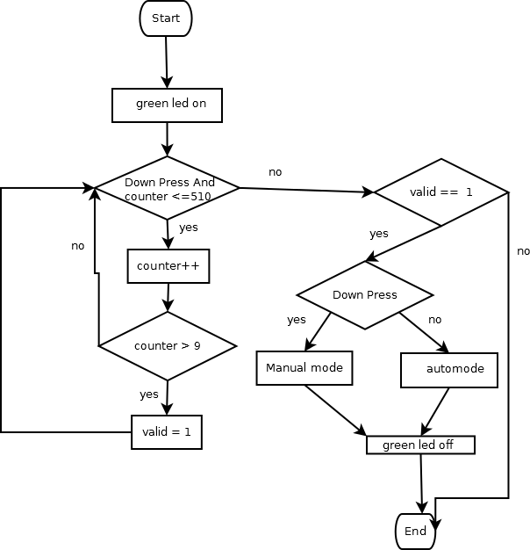

autoUp flow chart
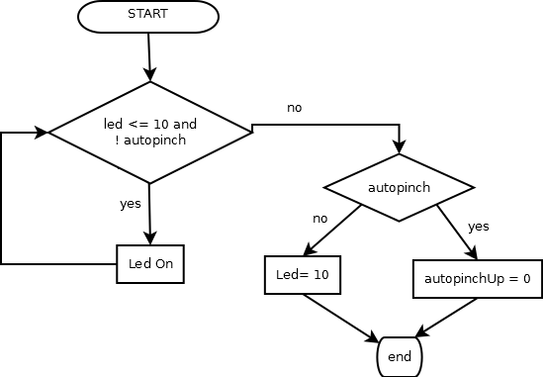
autoDown flow chart
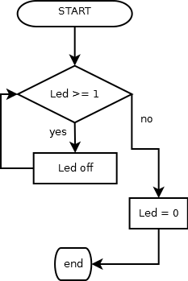

manualUp flow chart
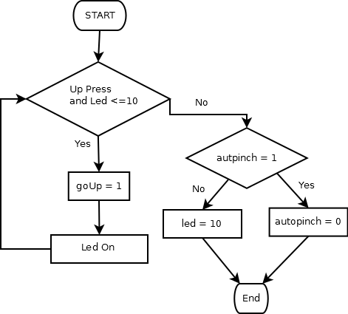
manualDown flow chart
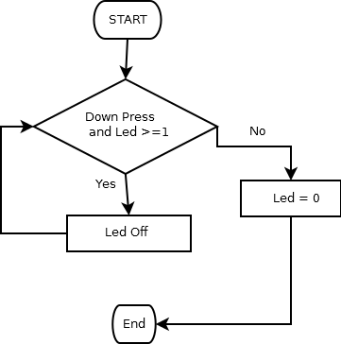

pinchInterruption flow chart
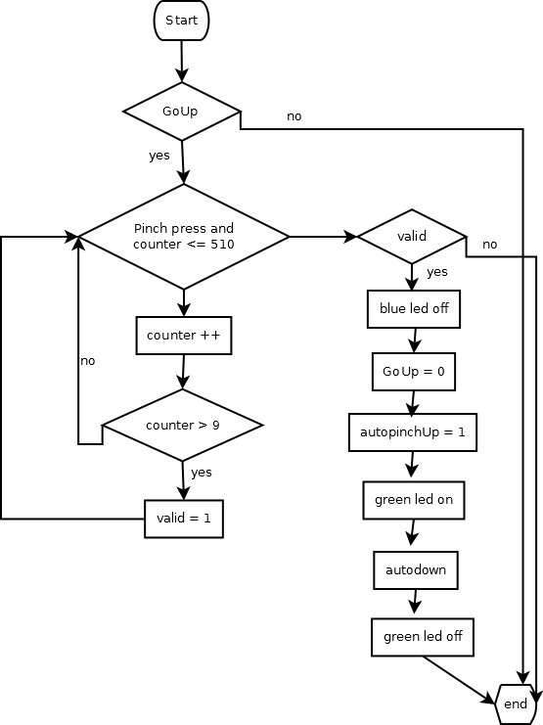

Dynamic Behavior
State Chart¹, Flow Chart¹, Nassi Shneiderman
¹ Preferred
General system flow chart
